ERGO3

Virtual Globetrotter

Requirements

Setup
For running this project, it is recommended to have two laptops and an immersive room:
- The first laptop will be used to run the webservice. Since the AI models will be running on the laptop itself, it is recommended to have a good NVIDIA GPU. For fast image generation and request processing, we suggest having 8GB of VRAM. This laptop will also be used for storing all the images, so sufficient memory is required. We use ASUS TUF GAMING A16 with NVidia GeForce RTX 4070 Laptop GPU for this purpose.
- The second laptop will be used to run the Elastic Search container. If you host the application on a more powerful machine, it is possible to run both webservice and the Elastic Search container on a single computer. The only requirement for this laptop is that it is able to run Docker Desktop application and Docker containers. More information can be found on the official Docker website.
- Immersive room’s screens should be configured in sequential order. We did not configure anything in the immersive room ourselves. If you have any questions regarding the immersive room in The Core in Howest, please contact HIT Lab.
- The website can be accessed from any device connected to the internet. We used an iPad tablet as it is easy to use for the target audience. Accessing the website from another device not connected to the setup is not a requirement, but it will make the user engagement easier. Use the website only on a single device to prevent the API from overloading.

Software
- We recommend to run the code and install all the necessary requirements with Python 3.11 as newer versions of Python do not have the necessary support for some packages.
- For running frontend, which was made in Vue.js, Node.js is needed.
- For IDE, we recommend using Visual Studio Code.
- For Docker, we recommend downloading and installing Docker Desktop: https://www.docker.com/products/docker-desktop/

The guide was made with the assumption that the source code is already downloaded on the user’s machine. Otherwise, it can be found on our GitHub.

Installation Guide

Elastic Search
- Open `ERGO3_webservice/test_backend` directory in VS Code.
- Run start_docker.py. This will use the compose.yaml file.

Webservice: API
- Open `ERGO3_webservice/test_backend` directory in VS Code.
- Check if Python 3.11 is installed by entering the following command in the terminal:
- If you do not see the 3.11 version installed, download it from the official Python website.
- Enter this command in the terminal in VS Code to create a new virtual environment. Make sure you are in the directory `test_backend`:
- Activate the virtual environment by entering the following command in the terminal:
- Download all the necessary packages for running the application:
- Download Real ESRGAN upscaling model by following the guide in the official GitHub repository. You will need to follow the guide for the Python script. There are some manual things that need to be changed but I do not remember it anymore hhihihihihihihih. I will finish it when we try to install it on a spare laptop
- Download PyTorch by following the guide from the official website.
- Download CyberRealistic model from here and place it in `test_backend\models` folder.

Webservice: Frontend
- Open the `ERGO3_frontend` directory in VS Code.
- Check if Node.js is installed by running the following command in the terminal:
- Run the following command in the terminal to install all the packages needed to run the frontend:

Configuring Nginx
For port forwarding we used nginx. This allows us to have both frontend service and API service on a single link.
- Install nginx from the official website. Choose the drive `C:` root directory as a download path.
- Open `C:\nginx-1.24.0\conf\nginx.conf` file in Notepad and change the content to the following configuration:
- Save the file before closing the Notepad.

Configuring Ngrok
To avoid our website domain changing every time the application is run we used Ngrok service that allows to have a single static domain.
- Download Ngrok from the official website by following the guide there.
- Go to the Home page of the website and create your free account or log in if you have one already.
- Navigate to the Domain page and create a new domain.
- Open Command Prompt on your machine and enter the following command:
A configuration file will open on your screen immediately.
- Change the configuration file:
Change the `authtoken` to your token from Ngrok and `hostname` to your static domain address. Both of those can be found on the Ngrok website.
- Save the file and exit the Notepad.

(Optional) Unity
To change either the Slideshow Images, or the Background Music, You need to open the project through Unity.
This project was developed using Unity version 6000.0.25f1, we recommend You install the same, or similar version.
To download Unity, You first need to visit the website:
https://public-cdn.cloud.unity3d.com/hub/prod/UnityHubSetup.exe

Follow the steps in the Install Wizard, and then open the Unity Hub, which should look similar to this:
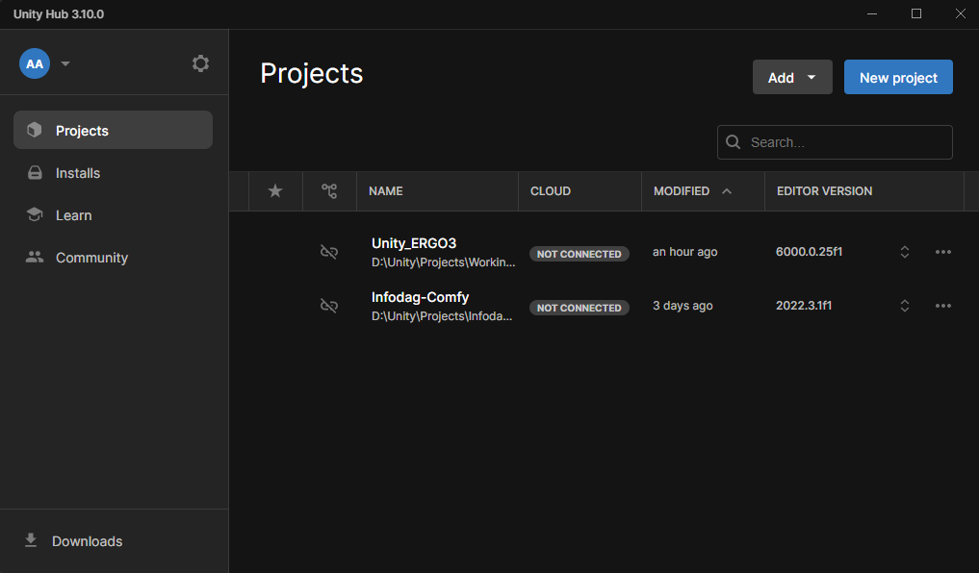
Click on “Add”, then select “Add project from disk”.
A Windows File Explorer window will open. You now need to navigate to the folder “Unity_ERGO3”. Click on it once (just select it, don’t open it), and press the “Add Project” button in the bottom-right corner.
It should now show up in the “Projects” tab in Unity Hub. You can click on it to open the project in Unity.
To change images or music, please follow the steps in the User Manual.

Setup Guide

STEP 1 (Optional): Configure Windows Defender Firewall
This step is optional, because it is already configured in the Howest immersive room.
- Navigate to the Windows Start Menu.
- Type “Windows Defender Firewall with Advanced Security” in the search box, and click on the first result:
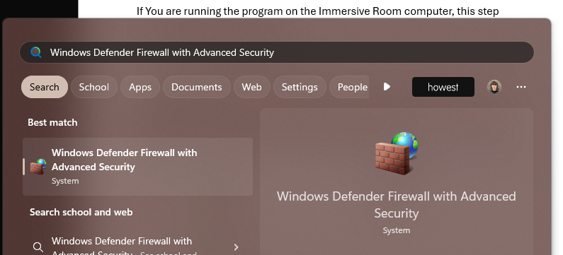
- Click on “Inbound Rules”, then press the “New Rule…” button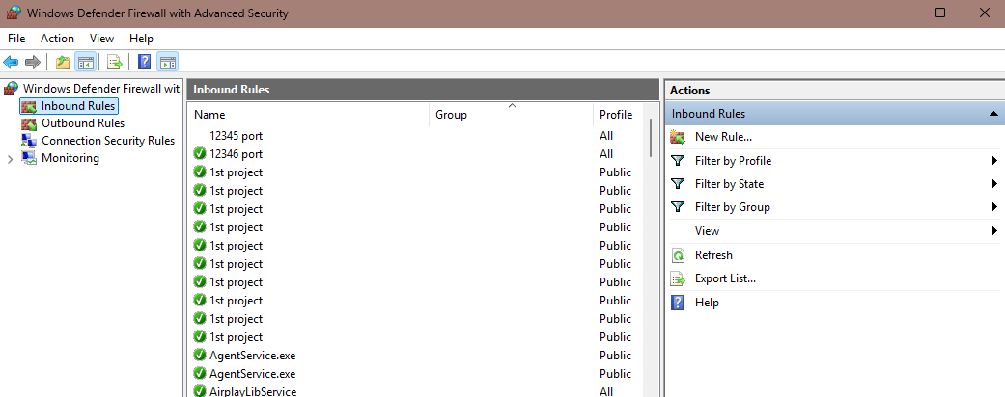
- Select “Port”, then click “Next >”
- Select “TCP”, and “Specific local ports”, then enter this: “12345, 12346” in the dialog box.
- Click “Next >” until You have to name the rule.
- Pick a memorable name (We used “12345 port” in this example), but You can name it however You want to.

STEP 2: Run Elastic Search in a Docker container:
- Start docker on the secondary laptop by running Docker Desktop.
- Open `ERGO3_webservice/test_backend` directory in VS Code.
- Activate the virtual environment by entering the following command in the terminal:
- Run the file start_docker.py
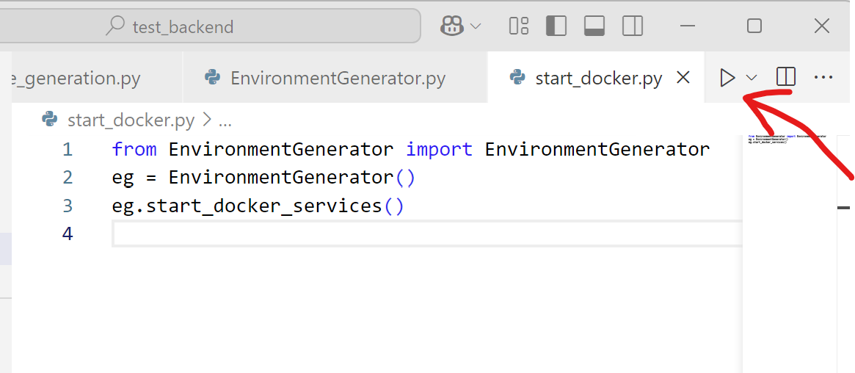
Make sure to have the `compose.yaml` file in the root folder.

STEP 3: Run the Executable file in the Immersive room:
- To run the project, navigate to the ERGO3_Virtual_Globetrotter folder, and double-click on the “Virtual Globetrotter.exe” file.

STEP 4: Run the API code on your main laptop:
- Open ERGO3_webservice folder in Visual Studio Code.
- Navigate to “ERGO3_webservice/test_backend” folder by running this command in the Visual Studio Code terminal:
- Activate the virtual environment by running the following command:
- Retrieve the IP-addresses of the secondary laptop and the immersive room PC:
- Open the Command Prompt and run the following command on both devices:
- Copy the address under the name of IPv4 Address: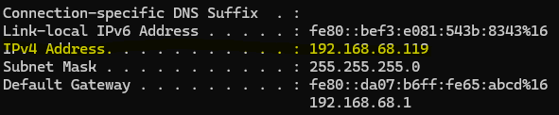
- Open the “app.py” file on your main laptop and replace the following IP-addresses with the ones you retrieved.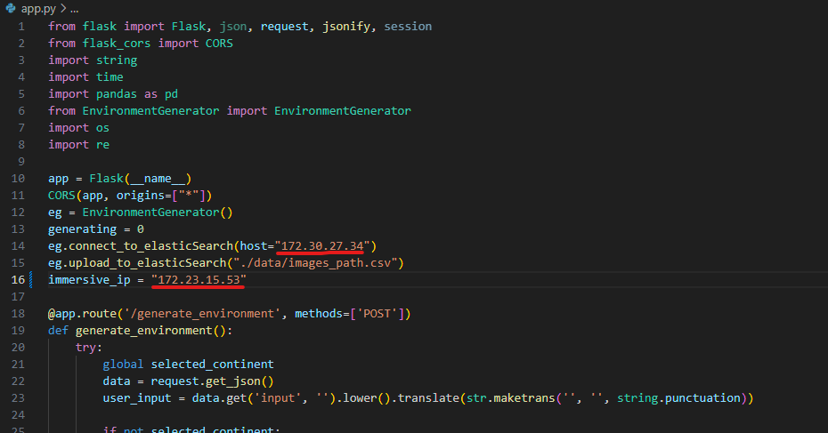
Immersive Room’s PC IP address
Secondary laptop’s IP address
- Run the “app.py” file and wait a minute for the all the packages to initialize.
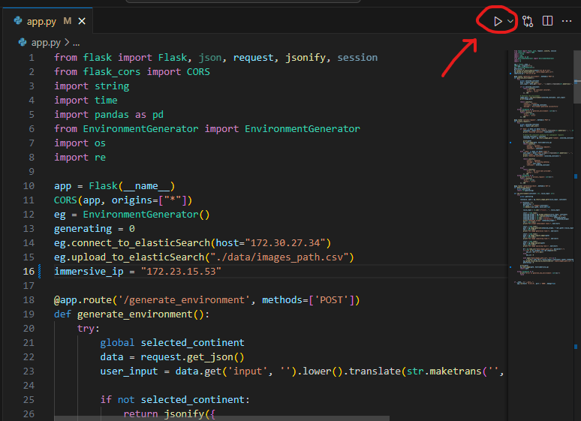

STEP 5: Running the frontend of the website:
- Open the folder “ERGO3_frontend” in Visual Studio Code.
- Run the following command to start the web-application:

STEP 6: Forwarding the webservice to a static domain:
- Open the Command Prompt and run the following commands top start up the nginx:
- Open the Command Prompt and run the following command to start up the ngrok:
Now the web application is available on the static domain that you have configured.

